Planeshift Preview: Battlemages
Gary Wise
I've always been of the opinion that versatility is the key ingredient in making a good draft card. Sure, there are the occasional single-use cards whose abilities are so plainly powerful that it doesn't matter that they lack options, but more often than not, I want the cards that, no matter what kind of deck my opponent plays, will find themselves useful in any number of situations.  That more than anything else, is the reason I love the Battlemages. With one for each color, these uncommon creatures potentially provide the user with the equivalent of four card types to use. There's the 2/2 for 3 who trades with your opponent's faster creatures, there are two 2/2 creatures with single kicker abilities, and there is the double kicker powerhouse who completely changes the face of the table.  Look at what these things do! Usually, when there is a card type produced for each of the five colors, one is the obvious weak one, but these things are all really strong. Whether you kill a creature with flying, bounce two creatures of your choice or deal two damage to anything or anyone, each of the ten abilities associated with the Battlemages offer incredible advantages, from altering the pace of the race to gaining huge card advantage to providing your deck with enchantment/artifact kill.  Experienced drafters have already come to understand how aggressive a draft environment Invasion has provided us. This comes from a number of factors, chief among them being the high caliber bounce cards, a large number of good 2/2 creatures for 2 mana and some very strong offensive tricks like Explosive Growth and Aggressive Urge. With this in mind, look at how the Battlemages can affect any given game while trading with another 2-toughness creature:  Sunscape: draw 2 cards, kill a flier, or all of the above.  Stormscape: Gain three life, kill a non-black creature or all of the above.  Nightscape: Destroy a land, bounce two creatures or all of the above  Thunderscape: force an opponent to discard 2 cards, destroy an enchantment or all of the above.  Thornscape: Deal 2 damage to any target, destroy an Artifact or all of the above.  Never before have we seen a series of creatures with such diverse abilities. Good in the early, mid or late game, the Battlemages provide each deck, in the form of a creature, a number of utility effects that you otherwise could not main deck. Would you ever play Overload, Wallop or Pain/Suffering main? Hopefully not, as these cards do not loan themselves to most situations, but now, with the Battlemages, you can potentially protect yourself from those situations where that utility is needed. Need to deal with an opposing Keldon Necropolis? Cast Nightscape Battlemage. Need to stop that opposing Dragon? Sunscape Battlemage can handle it. Need to get rid of Power Armor? Thornscape Battlemage is your card. The list goes on and on.  Which is the best? That's hard to say. Obviously the 'Withdraw', 'Nekrataal' and 'Ghitu Slinger' effects are incredibly strong, especially if you have Repulse, Recover or some other card that lets you utilize these abilities over and again, but each of them is useful in their own way. In the end, because of UB's ability to use a card more than once, it's probably the Stormscape, who, in addition to killing a non-black creature (Including pro black guys) provides a sturdy body that Shivan Emissary doesn't. That said, while Thunderscape appears to be the weakest, any of these can be respectable first picks in the right decks.  Sideboard doesn't usually have me write up the Constructed card analyses. A little slow for Constructed play, there's an outside chance that these things get played, but that's about as good as it gets. Sunscape may be played to take out all those Kibler clones and Thornscape might see some action just because its kicker costs are so efficient, but the truth is that there's little room for Grey Ogres in Constructed play.  So, whether you pay three or nine, the Battlemages are going to wreak havoc on your behalf. Whether they trade with a pro Knight, Banish an opposing fatty or kill a Dragon and draw you two cards, the easy to use casting costs and strong extra-curricular abilities ensure that having the Battlemages in your deck will never be anything but a good thing. Good luck opening them on Prerelease day. | 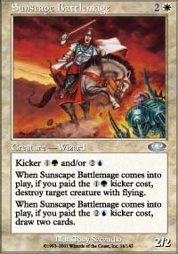  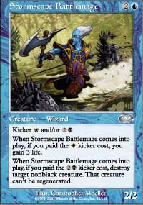  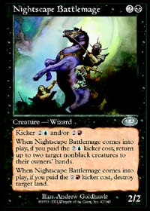  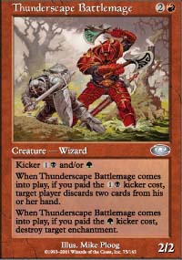  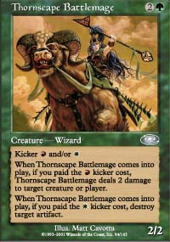
For information about Planeshift Prereleases, click here.

